Math 10

Lesson 4–3 Answers

**Lesson Questions**

–4

2

4

–4

–2

2

4

–2

*x*

*y*

K (0, –4)

A (–3, 6)

B (3, –2)

3 up

5 right

**Question 1**

Draw the following lines:

a) Plot the point K(0, –4) and then go 3 up and 5 right to find the second point. Draw a line between the two points. Remember to add arrows to the line to indicate that it continues on in both directions.

b) Calculate two points. Since the denominator in the slope is 3, I chose x = –3 and 3. 

**Question 2**

–4

2

4

–4

–2

2

4

–2

*x*

*y*

*x*-intercept, set *y* = 0



*y*-intercept, set *x* = 0



**Assignment**

1.

–8

4

8

–8

–4

4

8

–4

*x*

*y*

b)

–4

2

4

–4

–2

2

4

–2

*x*

*y*

a)

–8

4

8

–8

–4

4

8

–4

*x*

*y*

c)

–8

4

8

–8

–4

4

8

–4

*x*

*y*

d)

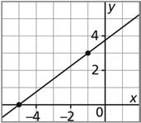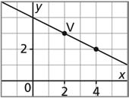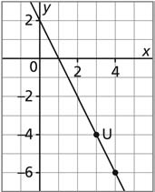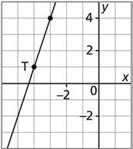2. a) b) c) d)

3.

–8

4

8

–8

–4

4

8

–4

*x*

*y*

b)

–4

2

4

–4

–2

2

4

–2

*x*

*y*

a)

–8

4

8

–8

–4

4

8

–4

*x*

*y*

c)

–8

4

8

–8

–4

4

8

–4

*x*

*y*

d)

4.

10

30

800

200

400

600

40

20

*n*

*C*

a)

b) The cost of 35 copies is approximately $7.80.

c) Approximately 46 copies can be made for $10.

5.

.5

1.5

320

80

160

240

2

1

*t*

*d*

a)

b) After 2 h, the distance from Calgary is approximately 60 km and from Edmonton 220 km.

–8

4

8

–8

–4

4

8

–4

*x*

*y*

a)

–8

4

8

–8

–4

4

8

–4

*x*

*y*

b)

6.

–8

4

8

–8

–4

4

8

–4

*x*

*y*

c)

–8

4

8

–8

–4

4

8

–4

*x*

*y*

d)

7.

|  |  |
| --- | --- |
| first (*x*) | second (*y*) |
| –2  –1  0  1  2 | 16  14  12  10  8 |

a)

–4

2

16

8

4

12

4

–2

*x*

*y*

b)

c) coordinates (3, 6)



c) coordinates (–2, 12)

